**ASSIGNMENT-4**

Create email newsletter design using Mailchimp or Canva tool

|  |  |
| --- | --- |
| NAME | S.SASIKUMAR |
| NM ID | E743439B51D3AC28ED844AA6B74B483E |
| ASSIGNMENT 4 | Create email newsletter design using Mailchimp or Canva tool |

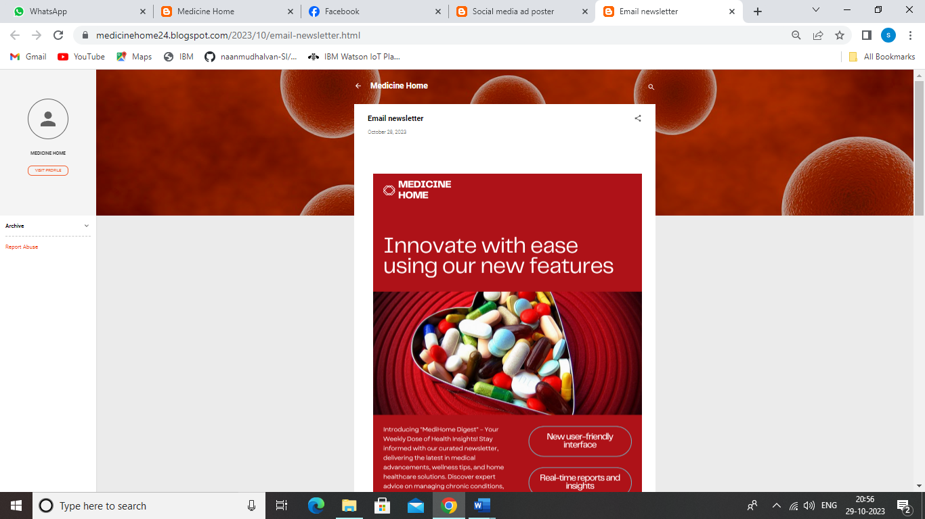

**CANVA EMAIL NEWSLETTER LINK:**

**<https://medicinehome24.blogspot.com/2023/10/email-newsletter.html>**